Workday keeps a record of your academic history. This serves as your unofficial transcript and can be used to plan for registration.

Use this reference to print your academic history.

INSTRUCTIONS

- Log into Workday and enter the Academics app.

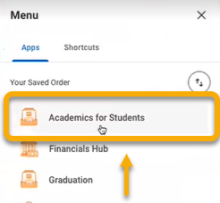

- Click the “Academic Profile” tab.

- In the right-hand menu, click “View My Academic Record”.

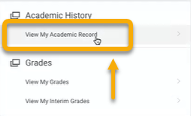

- On the View My Academic Record page, locate and click the small “PDF” icon in the top right-hand corner.

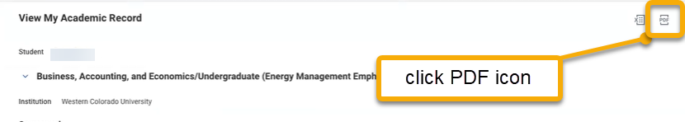

- The pdf will automatically download. When complete, click the “Download” button.

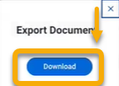

- Save the document to your preferred destination and print.

